FIRST MOCK EXAMINATIONS

SUBJECT: **INTEGRATED SCIENCE**

NAME…………………………………………………..……………………... DURATION:  **2 HRS**

**SECTION A: OBJECTIVE TEST**

1. The main pollutant from domestic fires is
2. carbon monoxide
3. sulphur dioxide
4. ammonia
5. oxygen
6. water vapour
7. Plantain is propagated vegetatively by
8. corms
9. stem cutting
10. suckers
11. rhizomes
12. tubers
13. Brass is an alloy of copper and
14. aluminum
15. carbon
16. iron
17. tin
18. zinc

Use the figure below to answer questions 4 and 5

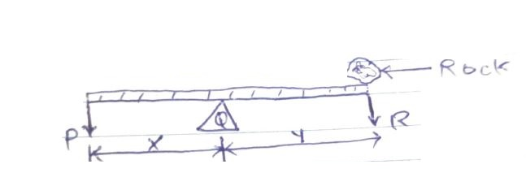

A rigid bar is balanced horizontally at a point by placing rock on the bar as shown

1. Which of the parts labelled represents the pivot?
2. P
3. Q
4. R
5. X
6. Y
7. The effort is represented by
8. P
9. Q
10. R
11. Y
12. X
13. The parts of seed which grows to become the shoot of a plant is the
14. cotyledon
15. plumule
16. radicle
17. testa
18. The disease caused by the plasmodium parasite is
19. cholera
20. malaria
21. onchocerciasis
22. schistosomes
23. Which of the following solvents can be used to remove grease from the hand?
24. alcohol
25. palm kernel oil
26. turpentine
27. water
28. The planet which is farthest away from the sun is
29. Jupiter
30. Mercury
31. Mars
32. Earth
33. Which of the following gases is involved in the process of rusting
34. H2
35. CO2
36. O2
37. N2
38. Heat travels through vacuum by
39. conduction
40. convection
41. radiation
42. convection and radiation
43. Which of these objects is a magnetic substance?
44. Aluminum
45. Brass
46. Copper
47. Iron
48. Which of the following bodies are natural sources of light?

I – Moon II – Sun III – Firefly

1. I and II only
2. I and III only
3. II and III only
4. I, II and III only
5. The chemical symbol of potassium is
6. K
7. N
8. P
9. S
10. Blood is prevented from flowing back into the vein by the
11. arteries
12. capillaries
13. heart
14. valves
15. The atom of an element is represented as 17Cl. How many electrons are in the atom?
16. 52
17. 35
18. 18
19. 17
20. Soil conservation is important because it prevent loss of
21. carbon dioxide
22. oxygen
23. minerals
24. humus
25. A patient with symptoms of diarrhea and vomiting may be suffering from
26. cholera
27. dysentery
28. influenza
29. tuberculosis
30. An aluminum cube with the side measuring 2m has mass of 24kg. Calculate the density of the aluminum
31. 48 kgm-3
32. 24 kgm-3
33. 12 kgm-3
34. 3 kgm-3
35. Which of the following features of a parent would not be inherited by the children?
36. Color of the eye
37. Shape of nose
38. Height
39. Scar
40. The food manufactured by a plant is distributed to all parts of the plant through the
41. chlorophyll
42. phloem
43. stomata
44. xylem
45. Which of the following parasite is a plant?
46. Bilharzia
47. Dodder
48. Lice
49. Tape worm
50. Day and night occur because the earth
51. move round the sun
52. move from east to west
53. move round the moon
54. rotate on its axis
55. The mosquito and housefly are harmful in that they
56. suck blood
57. bite and cause pain
58. settle on flood
59. spread diseases
60. The part of soil that is most important for the growth of plant is
61. clay
62. humus
63. sand
64. silt
65. Air is an example of
66. gas in gas mixture
67. liquid in liquid mixture
68. solid in liquid mixture
69. solid in solid mixture
70. A positively charged ion is called
71. anion
72. cation
73. neutron
74. proton
75. A good thermometric liquid must
76. Be colorless
77. Boil at 100 $℃$ and freeze at 0 $℃$
78. Cling to the walls of the glass
79. Expand evenly and regularly
80. The reason why gaps are left in the joints of railway line is to allow for
81. cooling
82. contraction
83. expansion
84. maintenance
85. The property of materials which makes them to be easily drawn into thin wire is known as
86. conductivity
87. ductility
88. malleability
89. resistivity
90. The second stage in the life cycle of a mosquito is the
91. egg
92. imago
93. larva
94. pupa
95. How many atoms are present in Cacl2?
96. 2
97. 3
98. 4
99. 5
100. The transfer of heat from the bottom to the top of a breaker containing water is by
101. absorption
102. conduction
103. convection
104. radiation
105. The function of the platelets in the circulatory system of humans is to
106. transport oxygen
107. transport carbon dioxide
108. clot the blood
109. defend the body
110. The component of a living cell responsible for respiration is
111. chloroplast
112. mitochondrion
113. nucleus
114. vacuole
115. An example of a plant micro – nutrient is
116. calcium
117. copper
118. magnesium
119. potassium
120. In a pin – hole camera, the image formed is always
121. erect and bright
122. erect and blurred
123. inverted and real
124. inverted and virtual
125. Gases enter and leave the leaf of a plant through the
126. mesophyll cells
127. stomata
128. pith
129. palisade cell
130. The warning and safety signs on chemical containers are usually represented by symbol placed within a
131. circle
132. rectangle
133. square
134. triangle
135. The efficiency of a machine is given by the ratio
136. load / effort
137. momentum / velocity
138. distance moved by effect / distance moved by load
139. mechanical advantage / velocity ratio

**SECTION B**

1. a. In an experiment, four nails 1, 2, 3 and 4 are fixed with candle wax onto a metal bar and one end of the bar is heated by means of boiling water as shown in the diagram below.

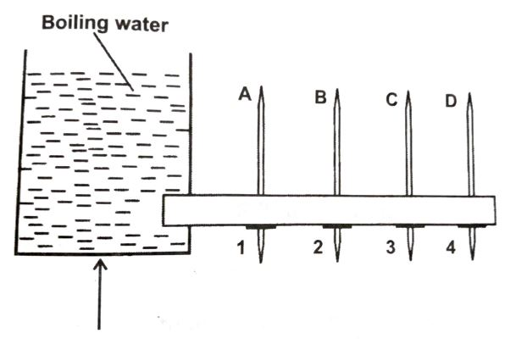

A, B, C and D are thermometers inserted in holes along the bar to measure the temperatures at the various points

1. What is the temperature of the boiling water?
2. State the observations that will be made about nails 1, 2, 3 and 4.
3. State the observations that will be made about temperatures recorded by thermometers A,B,C and D
4. What mode of heat transfer is demonstrated in the experiment?
5. State one effect of heat that is associated with the experiment
6. State the aim of the experiment
7. In an experiment, a student took three iron nails and cleaned their surfaces dry and placed them in three separate test tubes in set – ups A,B and C as shown in the diagram. After three days the nail in set – up A was found to have rusted while the nails in set – ups B and C did not.

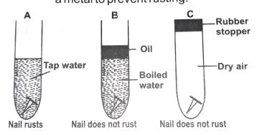

***Answer the following questions:***

1. Why was the water in set – up B boiled?
2. Explain the function of the oil on top of the water in set – up B
3. State the purpose of the rubber stopper in set – up C
4. Why did the nail in set – up A rust?
5. Suggest an aim for the experiment
6. From the experiment, explain why oil or grease is applied on the surface of a metal to prevent rusting.
7. In an experiment, the following activities were carried out on two green leaves A and B

Leaf A was from a plant placed in the sunlight for some time while leaf B was from a plant placed in a dark cupboard for 24 hours.

|  |
| --- |
| ACTIVITY   1. Leaves dipped in boiling water for 1 minute 2. Leaves dipped in warm alcohol 3. Leaves washed in cold water 4. Leaves dipped into iodine solution |

After dipping in the iodine solution, it was observed that leaf A changed colour while leaf B did not change colour.

***Answer the following question:***

1. Explain why each of the activities I, II, II and IV was carried out.
2. State the colour change of leaf A
3. Explain why leaf A changed colour but leaf B did not.
4. Suggest an aim for the experiment.
5. a. An atom has an atomic number of 8 and a mass number of 16. State each of the following in the atom.

i. Proton ii. Electron iii. Neutron (3 marks)

1. Draw the structure of the atom in (a) above
2. If the atom in (a) above gain two electrons what will be the charge of the ion.

(1 mark)

b. State the end – product of the following food substances

1. Carbohydrates
2. Proteins
3. Fat (3 marks)
4. i. What is preservation of food? (2 marks)

ii. List four methods of food preservation (2 marks)

iii. Explain why one of the methods you have listed is used for food preservation (1 mark)

1. An object is placed in front of a plane mirror
2. Draw a ray diagram to show how the image of the object is formed (4 marks)
3. State two characteristics of an image formed by a plane mirror (2 marks)
4. a. i. What is vector of a disease? (2 marks)

ii. State two methods each by which the vector of the following diseases can be destroyed. (4 marks)

$α.$ River blindness

$β.$ Malaria

b. Write down the systematic names of the following compound

* CaCO3
* FeS
* Nacl
* NaOH (4 marks)

c. i. Give two properties that are common to all states of matters (4 marks)

ii. In an experiment to determine density, a stone of mass 60g is put into a bowl containing water, if the level of the water rises, from 60cm3 to 75cm3 , determine the density of the stone. (6 marks)

1. a. i. What is personal hygiene? (3 marks)

ii. List four ways by which personal hygiene could be maintained (4 marks)

b. Define each of the following terms and give two examples each

1. compound
2. mixture (2 marks)

c. i. What is machine? (2 marks)

ii. Give one example each of a

$α.$ first class (1 mark)

$β.$ second class (1 mark)

$γ$. third class (1 mark)

d. i. What is a satellite? (2 marks)

ii. State two uses of a satellite

1. i. What is fertilization?

ii. Describe briefly the processes that lead to fertilization in human after mating

b. Define the term density?

ii. Describe how the density of a piece of stone could be determine

c. State three characteristics of each of the following

i. an insect pollinated flower

ii. a wind pollinated flower

d. A coconut of weight 50N hangs 15m above the ground

i. Name the type of energy possessed by the coconut

ii. Calculate the value of this energy

1. a. i. State three human activities that can cause an increase in soil erosion

ii. Give three ways of preventing soil erosion in agriculture

b. i. Describe briefly how a mixture of sand and common salt could be separated

c. i. Define work?

ii. State the SI unit for work.

d. i. Distinguish between heat and temperature.

ii. State the unit of heat and temperature.